INSTRUCTIONS FOR COMPLETING THE SUPPLIER WEB FORM

Table of Contents

1. Introduction 3
2. Desktop 4
3. Completing the web form 5
3.1. Official company data 5
3.2. Information about the contact person 7
3.3. Bank information 7
3.4. Additional information 8
3.5. Supplier material and services 9
3.6. Other documents 11
4. Sending the questionnaire for processing 14

Introduction

In order for an interested supplier to become a potential supplier of NIS, it needs to register in the supplier database by filling out a questionnaire in a WEB form which can be accessed on NIS website (http://www.nis.eu), in the section PROCUREMENT (http://tenderi.nis.eu/sr-lat/nis-suppliers/embed).
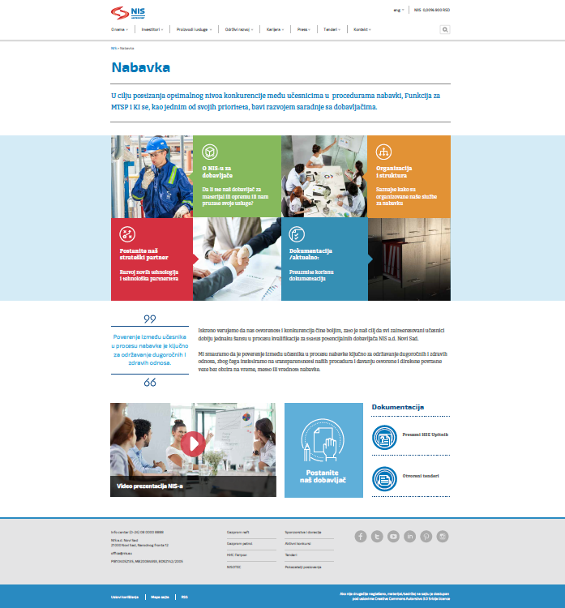

Figure 1 The Procurement page on the NIS official website

Desktop

In the web form home page, at the top right-hand corner, it is possible to select the script and the language of questionnaire.

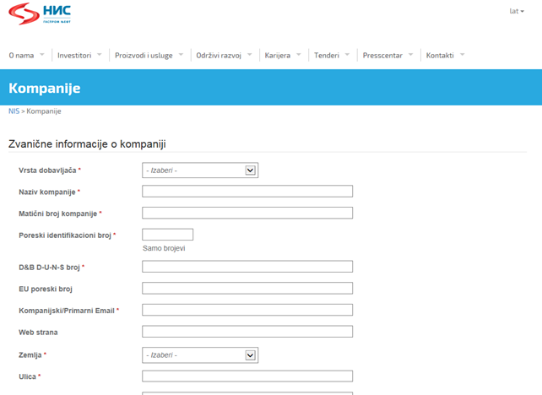
Figure 2 Home page of the web form
The questionnaire can be completed in:
  - Serbian (Cyrillic and Latin) and
  - English

Figure 3. Selection of the web form script and language

Completing the web form
The form requires from the supplier to enter data about the company, contact person, bank, required documents, the type of material or services that the potential supplier can offer, etc.
After the questionnaire is completed, the supplier is validated based on the tax ID number, and it is not possible to enter duplicate data – once the supplier applied with one tax ID number, cannot do it again.

Official company data

In order to complete the questionnaire, the official data about the company should be supplied. The red asterisk beside a field designates the required field that the user must fill out. If the required field is not filled in, it is not possible to complete the process and send the questionnaire for processing. The required data include:
    - Type of supplier (required field)

From the drop-down menu, select from the options a domestic or a foreign supplier.

    - Name of company (required field). Enter the official company name.
    - Company ID number (required field).
    - In the Taxpayer Identification Number, enter digits only (without the TIN prefix) (required field).
    - D&B D-U-N-S number (required field).
    - The EU number should be entered only by foreign suppliers, i.e. those suppliers who previously selected the option "foreign" from the drop-down menu in the field "Type of Supplier".
    - Company/primary email (required field). Enter the company's official email address. Official notices from NIS on the open procurement procedures will be sent to the email address entered by the user who has qualified.
    - In the field Website, enter the official website address if the company has one.
    - The data of the registered company seat (required field) include the following data:

- Country - enter the country of the company's registered seat:
From the drop-down menu, select the offered value related to the user's country:
- Street, number, postal code, and the city/town - the official information of the company's address should be provided:

    - Telephone numbers (only one field required). The user is allowed to enter several telephone numbers. One telephone number is mandatory, other fields are optional. Only numerical values can be entered in the fields.
After the official company information is filled in, the section with new questions automatically opens below.

Information about the contact person

In this section of the questionnaire, enter data about the contact person appointed to provide any additional information regarding the completed questionnaire (these fields are mandatory). Such information comprises:
    - Name of the contact person
    - Surname of the contact person
    - Function of the contract person.

Bank information

In this part, enter data about the bank with which the user has an open current account and through which it conducts its legal transactions with other legal entities (these fields are mandatory). Such information comprises :
- Name of the bank with which the user has an open account,
- Bank account number,
- IBAN,
- SWIFT code.

Additional information

In the additional information section, the user enters data by selecting an offered value (these fields are mandatory). Additional information includes:
- Capacity of the company – select from the options in the menu depending on whether the company in cooperation with NIS acts as a manufacturer, an authorized dealer, a distributor, a service provider or a contractor.
- A valid confidentiality agreement with NIS j.s.c. Novi Sad – here, it should be indicated if the user has a valid confidentiality agreement with NIS j.s.c.
From the drop-down menu, select from the options yes, no or I already have a valid agreement.
If the option "I already have a valid agreement" is selected, a new field opens in which the document is to be uploaded. Detailed uploading instructions are given in item 3.6 hereof.
- Are you HSE qualified by NIS j.s.c. Novi Sad? - it should be indicated if the user is HSE qualified by NIS j.s.c.
From the drop-down menu, select from the options yes, no or I already have a valid agreement.
If the option "I already have a valid agreement" is selected, a new field opens in which the document is to be uploaded. Detailed uploading instructions are given in item 3.6 hereof.
- Do you have an option to sign agreements electronically? - it should be indicated if the user has an option to sign agreements electronically in order to define the method of signing future contract documents.
From the drop-down menu, select from the options yes or no.
If the option "yes" is selected, a new field opens in which the user is to enter information of the certification body with which the user has an option of electronic contract signing.

Supplier material and services

In this section, the user should indicate the categories of material and services it can offer. To indicate the aforesaid, select from the option in the menu with predefined categories. If the user wishes to offer several material and service categories, several predefined categories can be selected from the menu simultaneously. When selecting the categories of services, equipment and materials from the menu, it is important that the selection be as precise as possible. The category is checking the box in front of the category. For a better overview of categories selected, the selected category will be shown in Italics.

  - Materials - the user can make a selection in the predefined menu:

  - Services - the user can make a selection in the predefined menu:

Other documents

The other documents section is intended for the user to upload the required documents. Such documents may be up to 2 MB. Approved document formats: jpg, jpeg and pdf. The uploaded supporting document should be in the form of a contract signed by the supplier. To upload the document for sending, select the option "Browse" for every document individually.
The window opens to select the file to send.

By clicking on "Open", the document is successfully uploaded in the questionnaire, and the empty field beside the document is checked.
The documents to send include:

  - Company registration certificate,
  - Supplier guarantee that the company has not gone into receivership, bankruptcy, or liquidation, i.e. that it has not suspended its business activity based on a court order or some other enforceable decision,
  - A clearance certificate,
  - A certificate of good standing and scoring report,
  - Debt to budgets at all levels (federal, regional, etc.),
  - Supplier's acceptance of NIS j.s.c. standard payment terms.
  - Supplier's readiness to sign the standard Anti-Corruption Agreement

The user can download the standard Anti-Corruption Agreement form by clicking on "Download the standard Anti-Corruption Agreement form"

By clicking on this option, a window to access the document opens. The document can be opened without being automatically saved by clicking on "Open", or saved by clicking on "Save", or saved with a different name by clicking on "Save as".
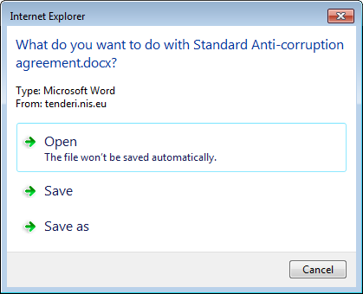
When clicking on "Save as", select the folder in which to save the document and then click on "Save".
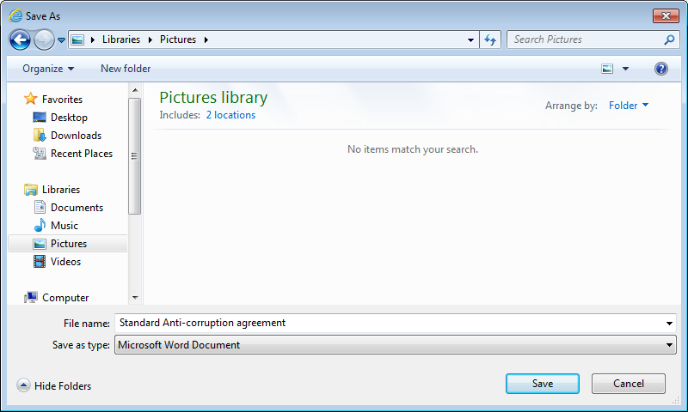

Sending the questionnaire for processing

When completed, the questionnaire is sent for processing by clicking on "Send".
If any of the required fields is not filled out, the questionnaire screen shifts automatically to the question which has not been completed, with a notification message "This is a required field".
After the complete questionnaire has been filled out, the document is sent by clicking on "Send". If one exits the web form screen before sending the questionnaire, all filled in data shall be deleted and all fields in the questionnaire need to be re-filled.

